Seaborn examples

sns.scatterplot(x="bill_length_mm", y = "flipper_length_mm", data = df1, hue = "species", size = "sex")

plt.title("Bill Length v Flipper Length", size=10, color="orange")

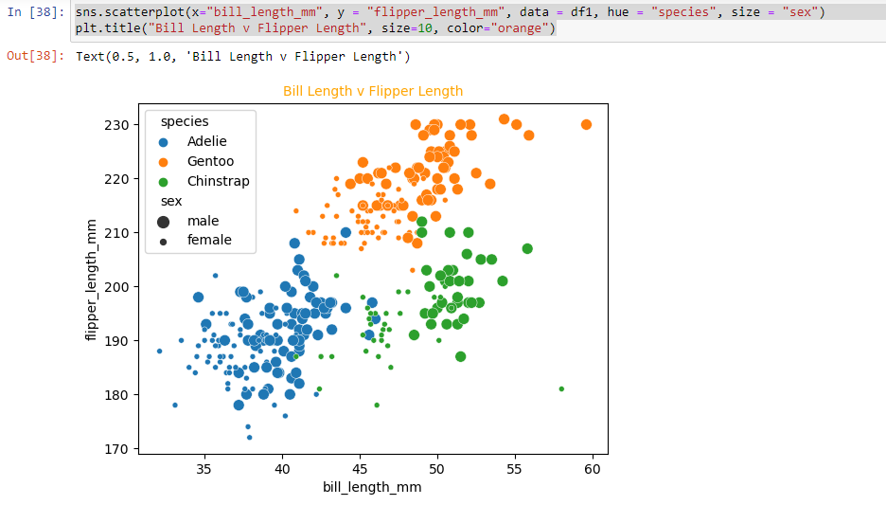

sns.scatterplot(x="bill_length_mm", y = "bill_depth_mm", data = df1, hue = "species", size = "sex")

plt.title("Bill Length v Bill Depth", size=10, color="Purple")

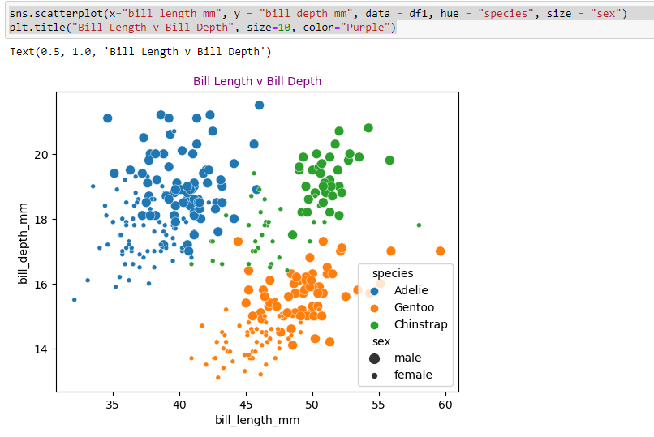

sns.scatterplot(x="bill_length_mm", y = "body_mass_g", data = df1, hue = "species", size = "sex")

plt.title("Bill Length v Body Mass", size=10, color="cyan")

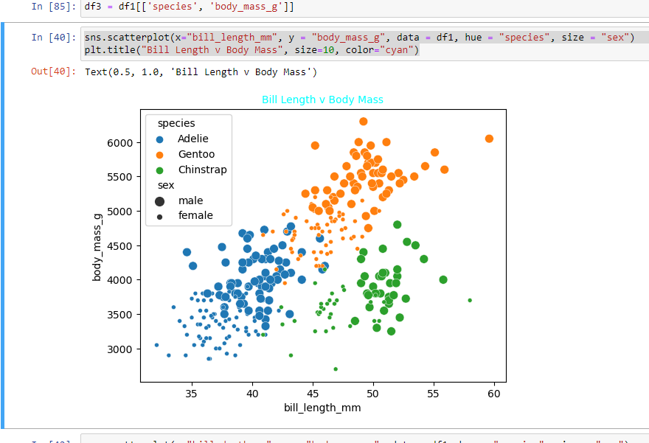

sns.scatterplot(x="bill_depth_mm", y = "body_mass_g", data = df1, hue = "species", size = "sex")

plt.title("Bill Depth v Body Mass", size=10, color="cyan", )

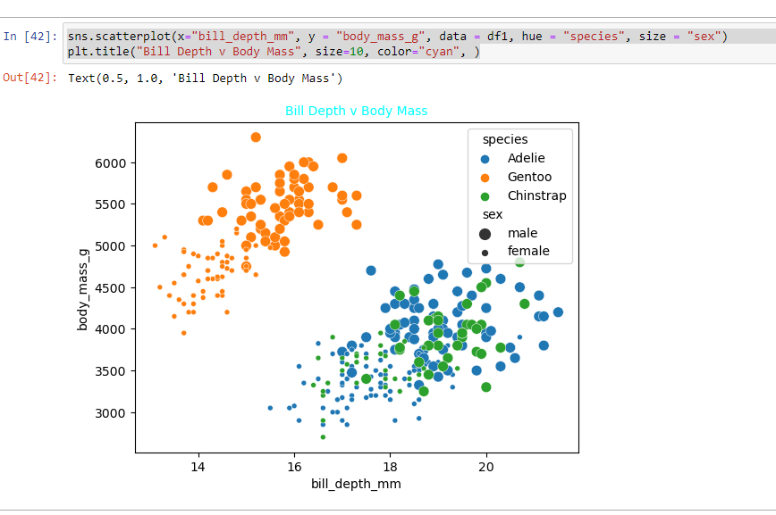

sns.scatterplot(x="bill_length_mm", y = "bill_depth_mm", data = df1, hue = "island", size = "year")

plt.title("Bill Length v Flipper Length", size=10, color="black", )

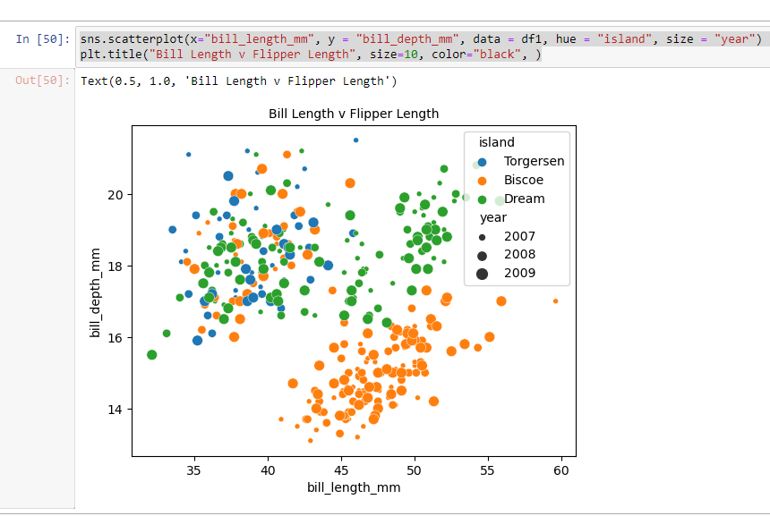

sns.barplot(x="sex", y = "body_mass_g", data = df1, hue = "species")

plt.title("Sex v Body Mass", size=10, color="cyan")

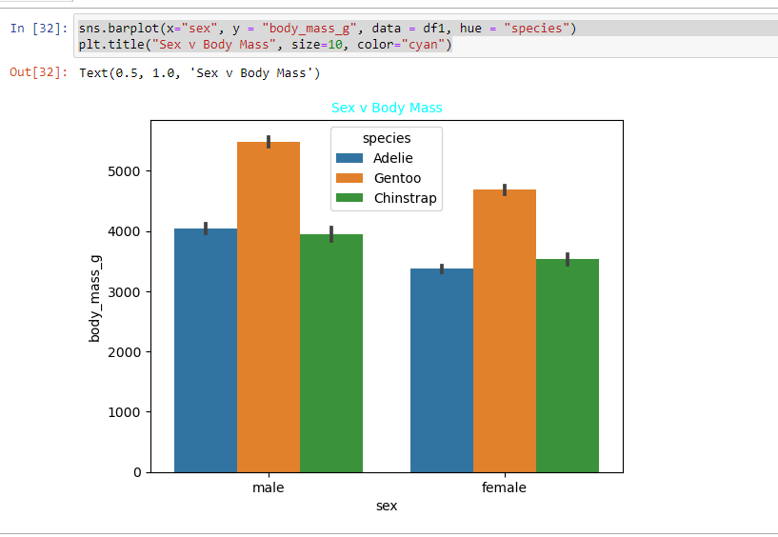

sns.violinplot(x="sex", y = "body_mass_g", data = df1, hue = "species")

plt.title("Sex v Body Mass", size=10, color="cyan")

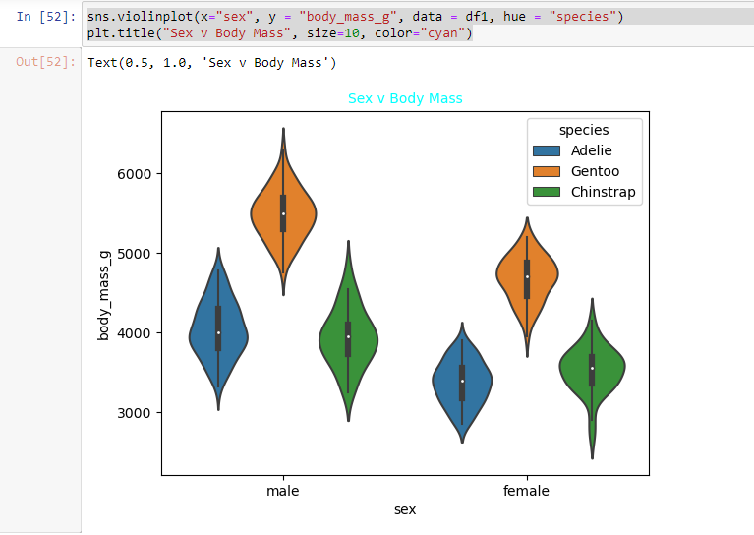

sns.pairplot(data=df1, hue = "species", palette="husl")

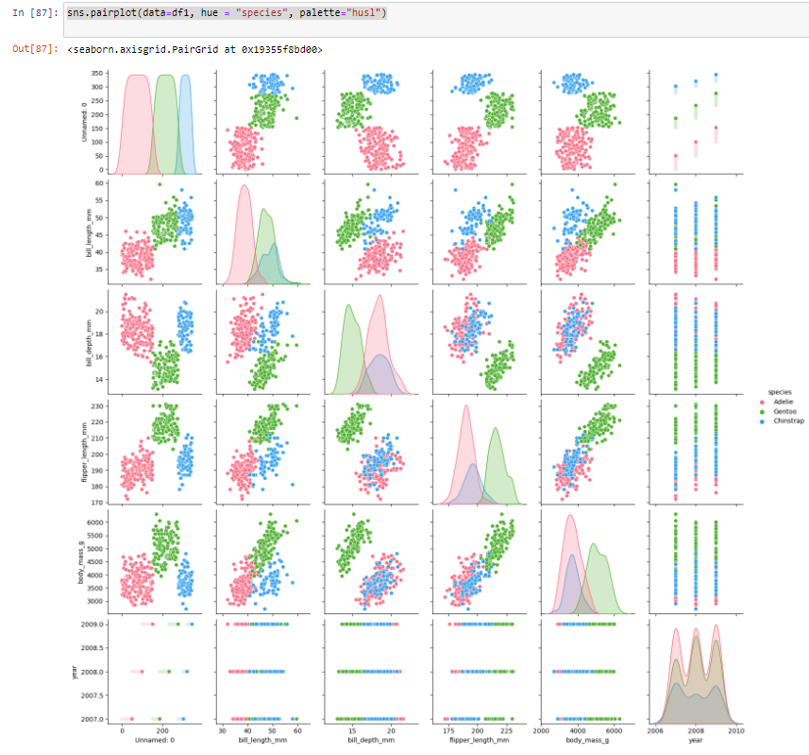

graph=sns.FacetGrid(df1, row="island", col="year")

graph.map(plt.hist, "species", color="green")

plt.show()

